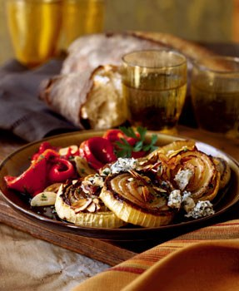
Roasted Sweet Onions with Cabrales Blue Cheese

Makes 8 servings

Ingredients

  - 4 large Walla Walla Sweet Onions, cut crosswise into 1-inch-thick slices
  - 1/4 cup olive oil
  - 4 ounces Cabrales or other strong blue cheese, crumbled
  - 1/4 cup extra-virgin olive oil
  - 2 tablespoons Sherry wine vinegar
  - 1/2 cup sliced almonds, lightly toasted
  - 1/3 cup chopped fresh chives

Preparation
  - Preheat oven to 400°F. Arrange onions in single layer on rimmed baking sheet; drizzle 1/4 cup olive oil over; turn onions to coat. Sprinkle with salt. Roast until soft and brown on edges, turning every 15 minutes, about 1 hour. Transfer to platter. Sprinkle with salt and pepper. Cool. (Can be made 4 hours ahead. Cover; let stand at room temperature.)
  - Sprinkle cheese over onions. Drizzle 1/4 cup extra-virgin olive oil, then vinegar over cheese and onions. Sprinkle with almonds, then chives and serve.
from Epicurious

