Burnt Onion Steak Sauce Recipe adapted from Danny Grant, Maple & Ash, Chicago, IL
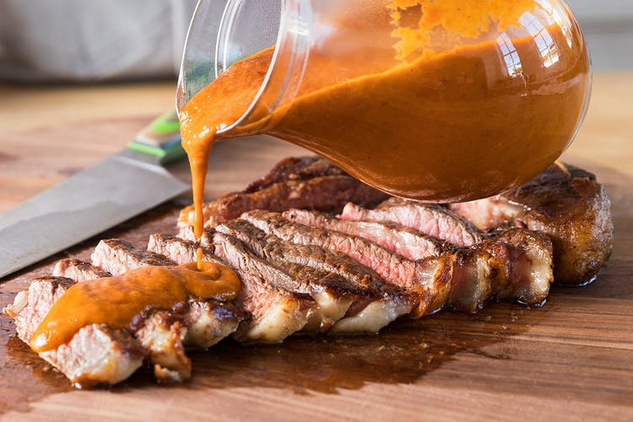
INGREDIENTS

One 3-inch piece orange zest
One 3-inch piece lemon zest
Half of one large Walla Walla Sweet Onion, whole (don’t dice)
1½ sticks unsalted butter
2 cups beef stock
3/3 1¼ cups raisins
¾ cup tomato paste
¾ cup Champagne vinegar
7 tablespoons Worcestershire sauce
¼ cup capers
3 tablespoons caper juice
3½ tablespoons gochujang
3 tablespoons balsamic vinegar
3 tablespoons barley malt syrup
1 tablespoon soy sauce
1 tablespoon colatura (Italian anchovy sauce)
2 teaspoons celery seeds, toasted
1 large red grapefruit, supremed

DIRECTIONS
1. Preheat the broiler. Place the orange and lemon zest on a sheet pan, and broil until charred, 2 to 3 minutes, then set aside.
2. Cover the surface of a small skillet with a square of foil and place the onion, cut-side down, on top. Heat over medium-high heat until well charred, 10 minutes.
3. Transfer the onion to a cutting board, discarding the foil, and roughly chop.
4. In a medium saucepan, melt the butter over medium heat. Add the chopped onions and sweat until softened, 8 to 10 minutes. Add the charred citrus zest and the remaining ingredients, then bring to a simmer.
5. Cook until thickened, 20 minutes. Transfer to a blender and purée until smooth. Keep in the refrigerator for up to 2 weeks, or jar or freeze for up to 1 year.

